CS 340 Project Two
Grazioso Salvare Rescue Animal Dashboard
Project README and Reproduction Guide
Arthur Sarkisyan

Project Overview
For this project, I created an interactive dashboard for Grazioso Salvare using animal records from the Austin Animal Center. The dashboard lets users filter animals by rescue type, view their information in a sortable table, compare breeds using a pie chart, and see selected animal locations on a map. I used MongoDB to store the records, a Python CRUD module to retrieve them, and Dash callbacks to update the dashboard.

Functionality and Testing
The MongoDB collection returned 20,000 source documents. The dashboard removes 10,000 exact duplicate rows, leaving 10,000 unique records in its unfiltered table. Filtered results were checked in the running Codio dashboard. The chart shows the ten most frequent breeds, with remaining breeds grouped under Other; the map updates to the selected table row. Counts below describe the displayed unique records, not distinct animals across different outcomes.
Filter state | Displayed records | Observed chart
Reset / unfiltered | 10,000 | Top ten breeds + Other
Water Rescue | 17 | Labrador Retriever Mix 100%
Mountain or Wilderness Rescue | 5 | Siberian Husky 40%; three breeds 20% each
Disaster or Individual Tracking | 4 | Rottweiler 50%; two breeds 25% each
Final Reset | 10,000 | Unfiltered distribution restored

Initial / Reset dashboard heading, filter, and table
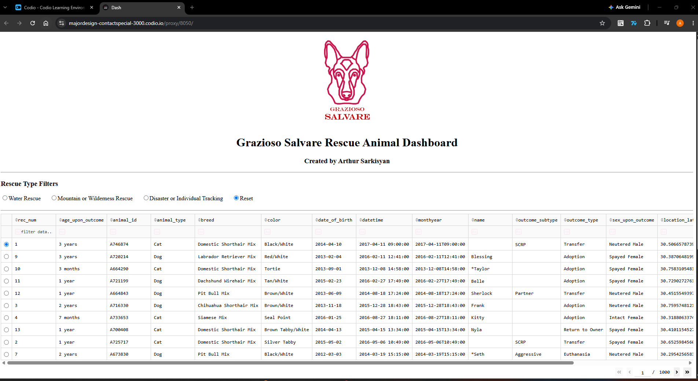
Initial / Reset breed distribution and geolocation map
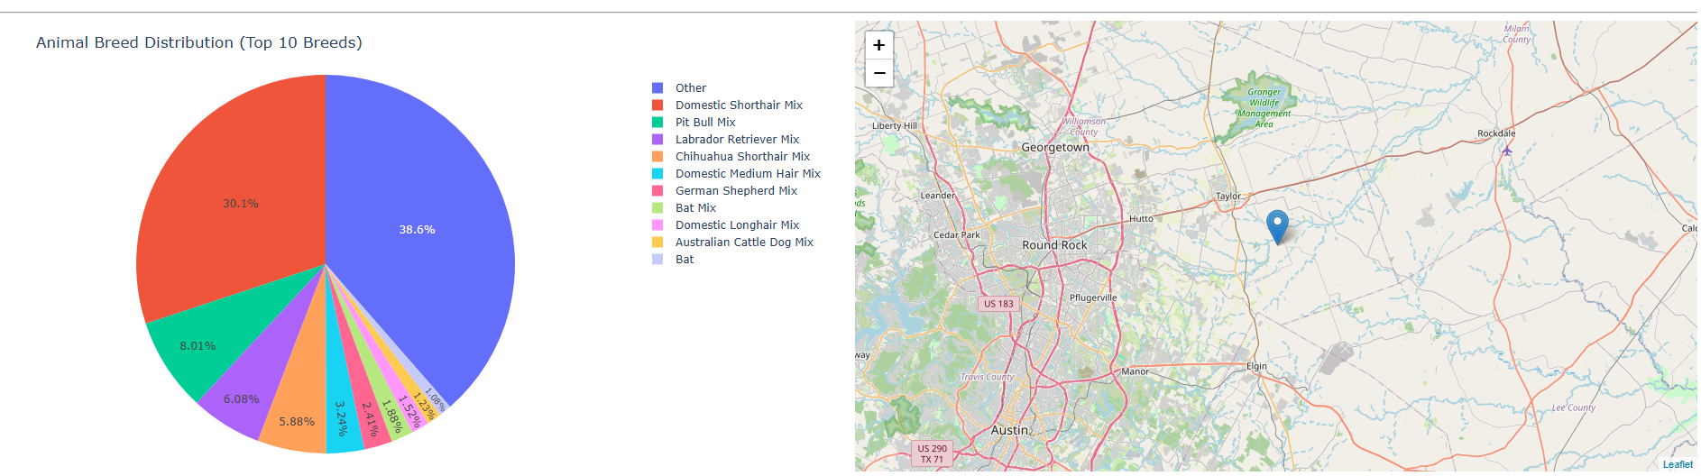

Water Rescue dashboard heading, filter, and table
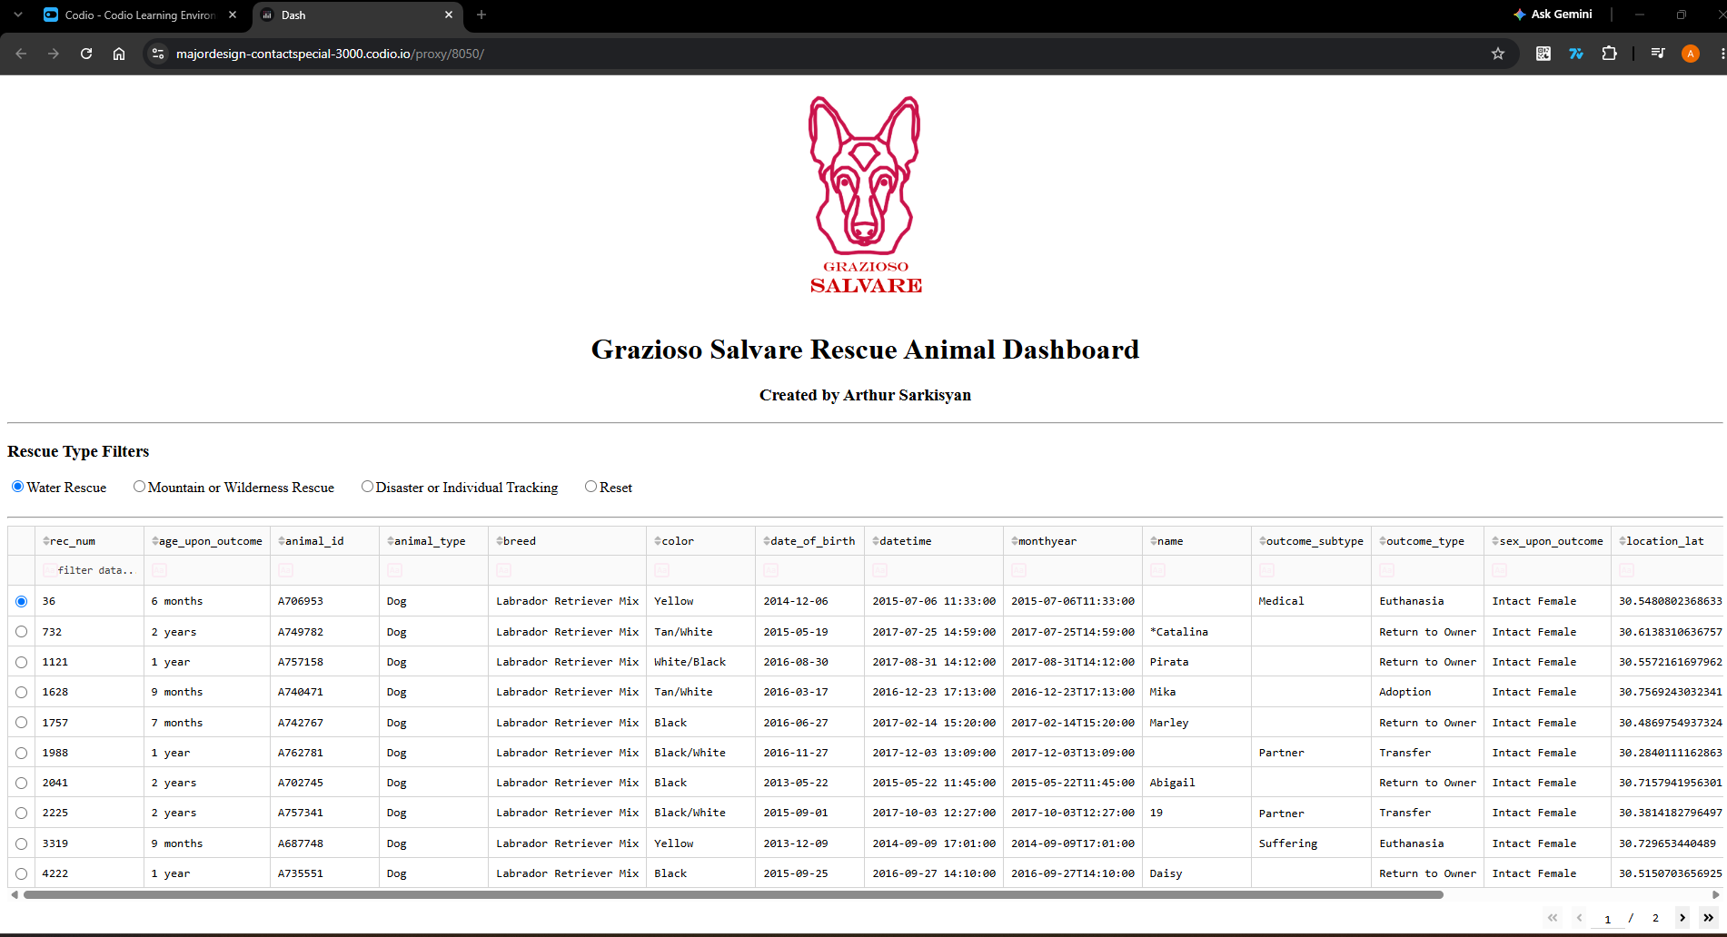
Water Rescue breed distribution and geolocation map
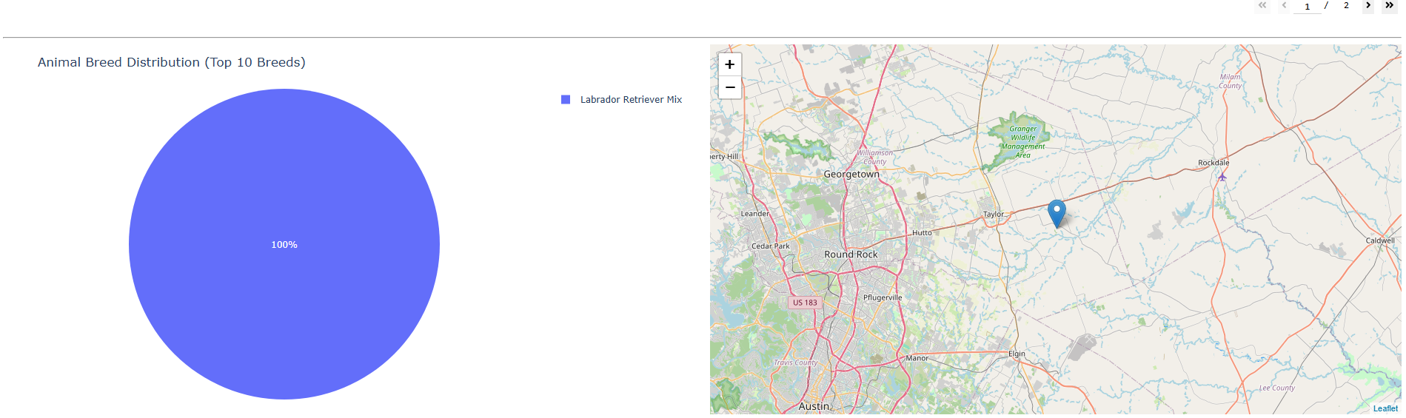

Mountain or Wilderness Rescue dashboard heading, filter, and table
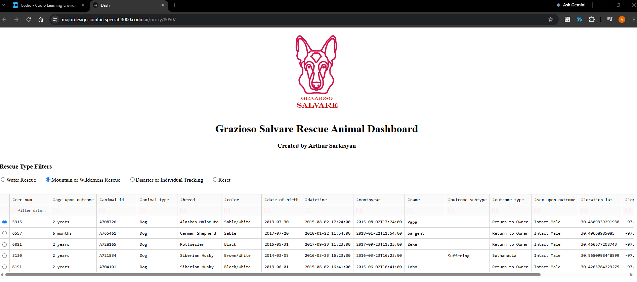
Mountain or Wilderness Rescue breed distribution and geolocation map
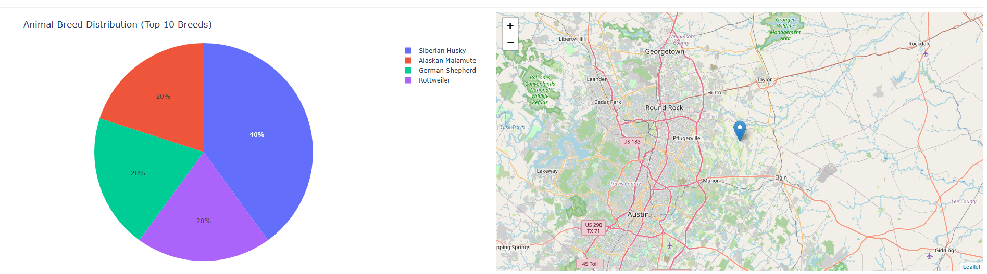

Disaster or Individual Tracking dashboard heading, filter, and table
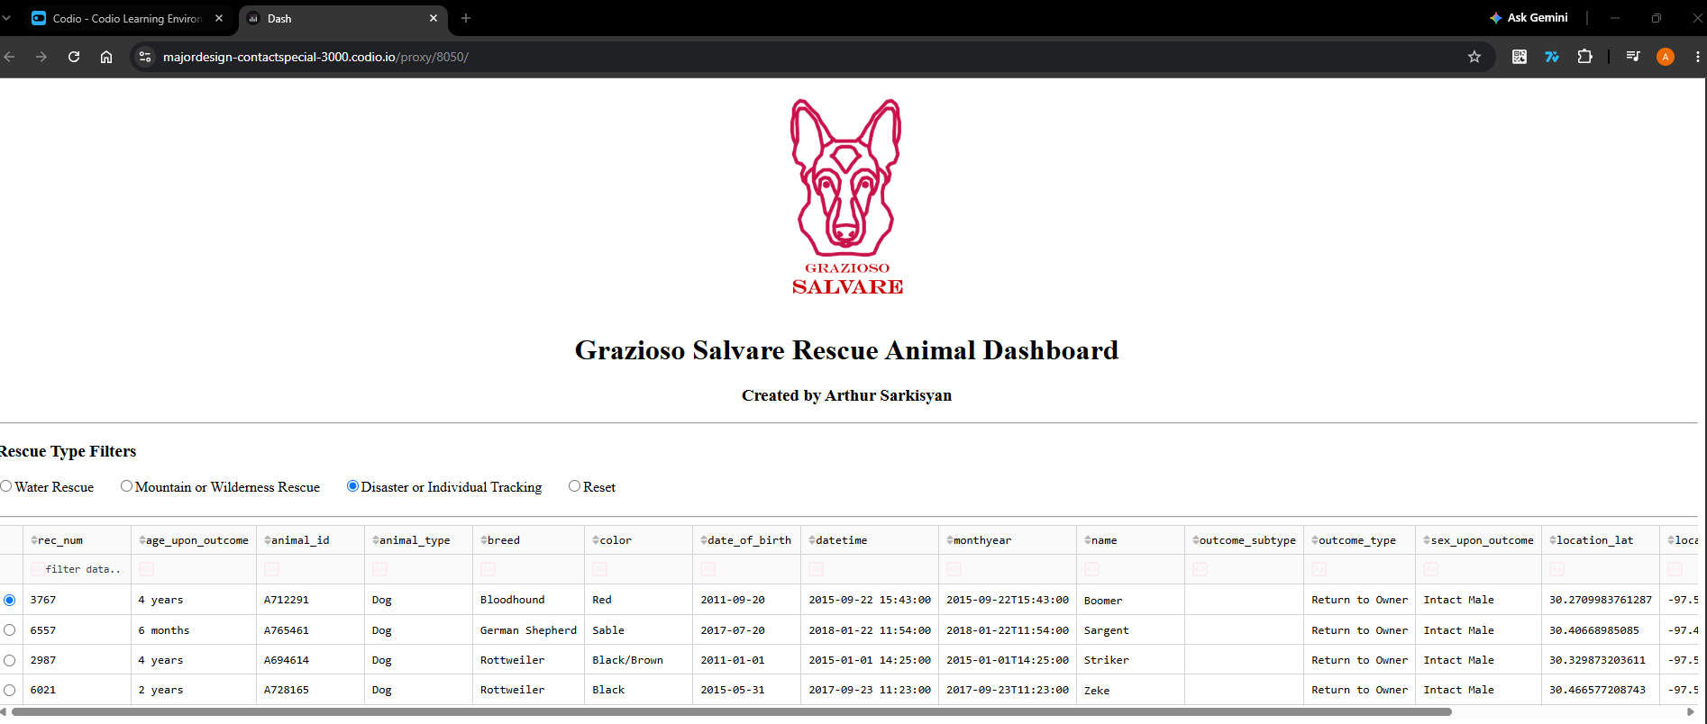
Disaster or Individual Tracking breed distribution and geolocation map
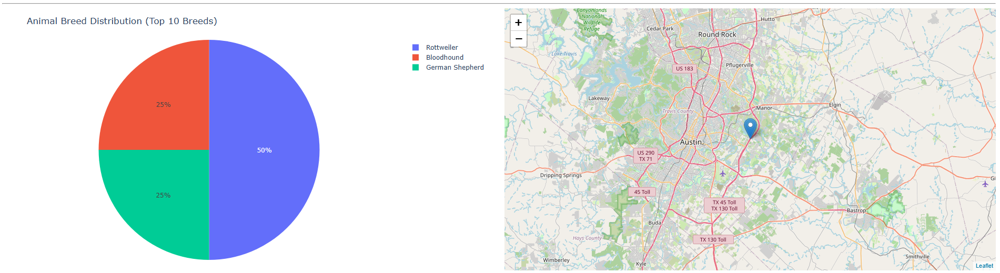

Final Reset dashboard heading, filter, and table
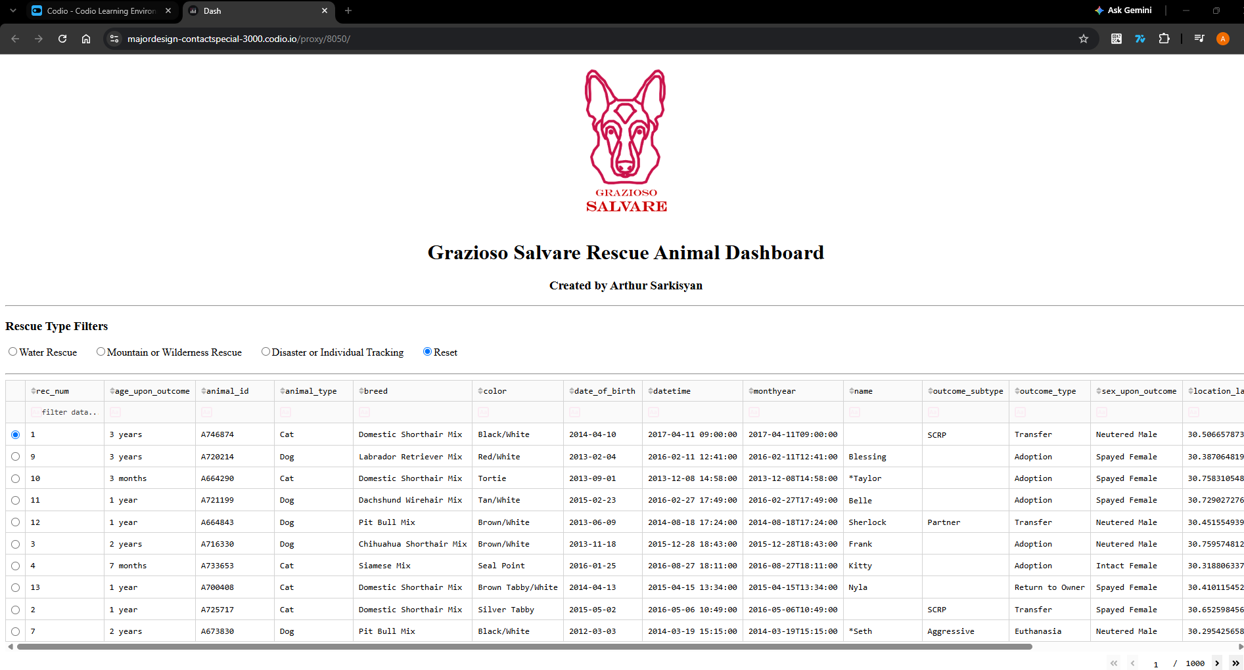
Final Reset breed distribution and geolocation map
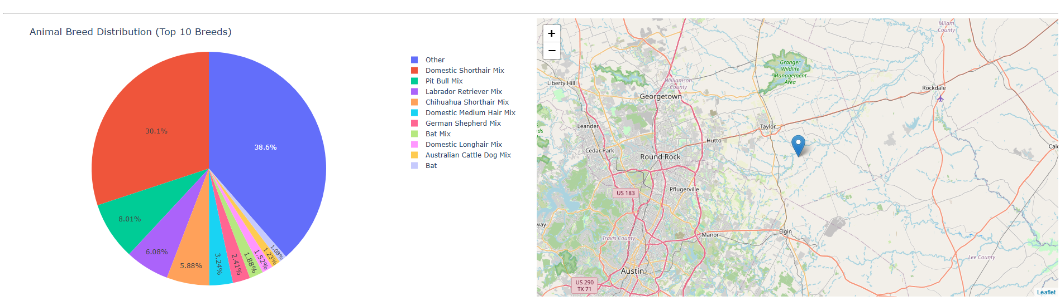

Tools and Design Choices
MongoDB stores the shelter records as documents and supports flexible field-based queries. PyMongo connects Python to the aac database and animals collection. The AnimalShelter class implements create, read, update, and delete operations; the dashboard uses its read method for retrieval and filtering. Pandas converts query results to tabular data and removes duplicates. Dash and JupyterDash provide the browser interface, radio-button filter controls, table, and callbacks. Plotly Express renders the breed pie chart, and dash-leaflet provides the interactive map. JupyterLab in Codio hosts the notebook and development environment.

Development Process
1. Imported the Austin Animal Center Outcomes data into the MongoDB aac.animals collection and configured the aacuser account.
2. Developed and tested the AnimalShelter CRUD module in Python.
3. Loaded records into a Pandas DataFrame and removed the MongoDB _id field for table compatibility.
4. Removed exact duplicate records to avoid displaying duplicate rows and distorting breed counts.
5. Built a Dash layout with logo, creator identifier, rescue filters, table, pie chart, and map.
6. Connected filter selections to MongoDB queries and refreshed the table and visualizations through callbacks.
7. Tested each rescue category and Reset in a separate browser tab using Codio’s proxied Dash URL.

Challenges and Resolutions
Duplicate rows: The dataset query returned 20,000 documents but only 10,000 unique rows after duplicate removal. Removing duplicates in the dashboard prevented repeated table entries and double-counting in charts.
Browser access: Opening the localhost (127.0.0.1) address directly from the local browser failed because the application was running in Codio. Opening the Codio proxy URL allowed the dashboard to display in a separate tab for screenshots.
Pie chart readability: The unfiltered chart originally included too many individual breed categories. Restricting the display to the top ten breeds and grouping the rest as Other made the chart more readable.

MongoDB Authentication and Password Security
The dashboard connects to MongoDB through the AnimalShelter class using the aacuser account. It reads the password from the AAC_PASSWORD environment variable when available. If the variable is not available to the Jupyter kernel, Python’s getpass module requests the password without displaying the entered characters in the source code or ordinary output.
After a password is entered, the dashboard sets AAC_PASSWORD in the current Jupyter kernel environment. Subsequent runs in that kernel may reuse it without another prompt. A restarted kernel may request the password again unless the environment variable is supplied by the new process. A terminal-only export does not automatically update an already-running Jupyter server.

Reproduction Instructions

Open the CS 340 project in Codio and make sure the MongoDB database is available.

Open ProjectTwoDashboard.ipynb in JupyterLab with the CRUD_Python_Module.py file and Grazioso Salvare logo in the same directory.

Run the notebook and enter the MongoDB password when prompted.

Open the dashboard using the Codio URL displayed in the notebook.

Test the rescue filters, interactive table, pie chart, and geolocation map.

